

C5 Programación_Explorador_Virtual _L2

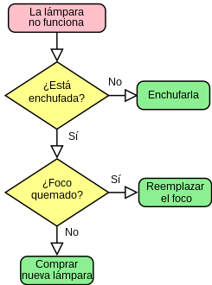*Oscar Ricardo Jurado Zambrano*

*PROFESSOR of ENGLISH: Carlos Moreno*

*Monitor: Diego Vasquez.*

***ACTIVIDAD***

***FORO 1:******Lección 3 Taller:***

*San Juan de Pasto, 13 junio 2025*

***Activity 3: Que entendió del video en ingles***

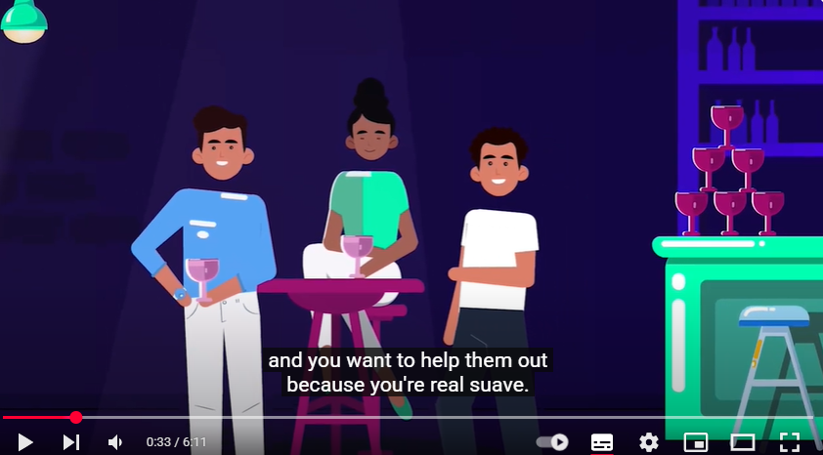

What is Programming? <https://www.youtube.com/watch?v=6YMec72CEiU>

[What is Programming? - YouTube](https://www.youtube.com/watch?v=6YMec72CEiU)

"Las instrucciones de programación se almacenan en la memoria del computador mediante código binario (compuesto por '0's y '1's), el cual permite plantear soluciones a diversos problemas. Primeramente, se aborda el problema del juego de las 3 cartas, donde el objetivo es adivinar cuál carta es la reina entre varias opciones. Para resolverlo, el computador sigue una secuencia de pasos lógicos que determinan la posición correcta.

Adicionalmente, se presenta un segundo problema relacionado con el control ganadero, específicamente en la administración de vacas. Por último, se habla como a través de programas computacionales se puede automatizar y monitorear el funcionamiento de ciertas máquinas tales como un cohete o una sanduchera.

Lección 2 Unidad 3: Best Practices in Programming

9- Based on the previous reading, complete the fill-in-the blank activity. For each sentence, fill in the blank with the word or phrase that best fits, based on what you have read.

1.Programming is like building with ***blocks***.

2.To start, you need to understand the ***problem*** you want to solve.

3.Planning your code is like drawing a ***map*** before a journey.

4.Write your code clearly, using sensible names for ***variables*** and functions.

5. ***Testing*** your code often helps to find mistakes early.

6.Sharing your code with others can give you new ***ideas*** and insights.

7.Keeping up with ***chages*** in technology means always learning new things.

8.Going back to improve your old code is known as ***refactoring***.

10- Activity: "Building Blocks of Programming"

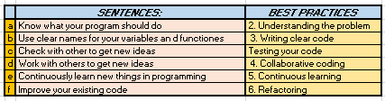

Unit 3: Interview for Programmers and Best Practices in Programming

Lesson 1: Interview for Programmers

6. Matching activity:

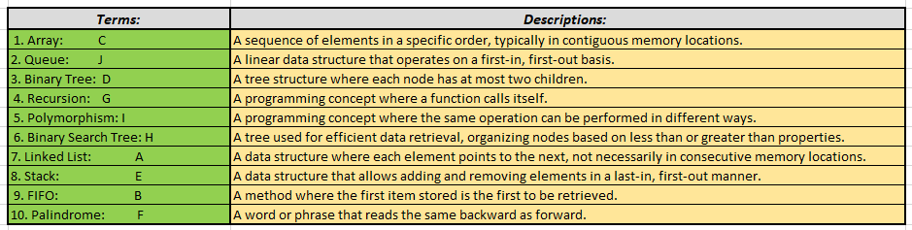

5- Multiple Choice Vocabulary: For each statement, choose the option that best matches the meaning of the word as used in the context of the reading passage.

1. Innovations

a) New methods, ideas, or products

b) Traditional ways of doing things

c) Problems in technology

2. Ubiquitous

a) Unique and rare

b) Found everywhere; widespread

c) Outdated and old

3. Dynamic Typing

a) The physical act of typing on a keyboard

b) A feature in programming where the type of a variable can

change

c) A programming language that is difficult to learn

4. Statistical Modeling

a) A way of predicting future trends

b) Using mathematical models in programming

c) Building physical models of computers

5. Parallelism

a) Working on a single task at one time

b) The ability to run multiple processes simultaneously

c) A type of computer error

6. Scalable Systems

a) Systems that cannot be changed

b) Systems that can handle increasing amounts of work

c) Systems used only in schools

7. Eco-friendly

a) Related to economic benefits

b) Something that is not harmful to the environment

c) A new technology gadget

6- True/False Activity: Read the following statements carefully. For each statement, decide whether it is true or false based on the text.

Python is currently leading in the development of AI and Machine Learning models due to its libraries like TensorFlow and PyTorch. ***V***

Rust is becoming popular for IoT applications mainly because of its integrated garbage collector. ***F***

Languages like Scala are becoming important in big data processing due to their efficiency in handling large datasets. ***V***

Haskell is known for its energy-efficient programming, which contributes to sustainable coding practices. ***V***

Go is designed with built-in concurrency mechanisms, making it unsuitable for distributed computing environments. ***F***

The rise of cloud computing has decreased the importance of language features that support distributed system design. ***V***

9- Match each heading with the correct paragraph. There are two headings that you do not need.

Headings:

The Role of fMRI in Brain Studies. *A*

Understanding Dynamic Coding Analysis. ***C***

The Future of Brain Research in Coding. ***D***

How Machine Learning Relates to Brain Studies. ***E***

The Importance of Teamwork in Research. ***F***

Brain Responses to Different Coding Tasks. ***B***

Unused headings:

The Use of fMRI in Other Fields _______

The Purpose of Coding _______

Paragraphs:

A. This part talks about a machine used to see blood flow in the brain during different activities, like coding. It helps to understand which parts of the brain are active.

B. Here, the text describes how researchers are looking at the brain's reaction to various coding tasks, such as loops and branches in code.

C. This section discusses the study of changes in code and how the reasoning part of the brain is more involved in this than the language part.

D. The paragraph focuses on the future research goals of the team. They want to learn more about how the brain handles complex tasks like planning or writing music.

E. This part is about using machine learning models to understand brain activity related to coding. The patterns seen in the brain are similar to those in these models.

F. Here, the importance of researchers from different fields working together to understand coding and the brain is highlighted.

***PARAFRASEO 1:***

|  |  |
| --- | --- |
| FMRI: | It's a machine that take various photos of different parts of brain |
| PROGRAMMING | are commands that development step by step to solve something |
| RESEARCHER | A person who development the knowledge |
| DYNAMIC ANALYSIS | instructions inside of a loop |
| MACHINE LEARNING | It's a algorithm training |
| NEUROSCIENCE |  |
| COLLABORATION |  |

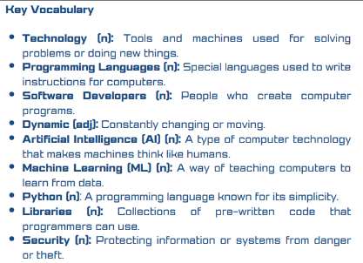

***PARAFRASEO 2:***

|  |  |
| --- | --- |
| Technology | Technological advances applied to problem solving |
| Programming Languages: | Specific code written in the computer to solving problems |
| Sofware Developers | person who create application like answer to some problem |
| Dynamic | It is something that is variable in the time |
| Artificial Intelligence | It is one type of algorithm reference to the way of human be think |
| Python | A excelent program easy to learning |

Unknown Vocabulary:

Trends Tendencias

enabler Facilitador / Habilitador

backbone Columna vertebral / Base fundamental

increasingly Cada vez más

wield Ejercer (poder/influencia) / Manejar (herramientas/armas)

landscape Paisaje / Panorama (en contextos figurativos, ej. "business landscape")

cater Atender / Satisfacer (necesidades)

provides Proporciona / Suministra

grasping Comprender / Asir (agarrar con la mano)

stand out Destacar / Sobresalir

ubiquitous Ubicuo / Que está presente en todas partes

healthcare Cuidado de la salud / Sector sanitario

vast Vasto / Extenso / Inmenso

flaws Defectos / Fallas / Imperfecciones

Bugs Fallos, defectos técnicos

Breaches Incumplimientos, filtraciones de datos

Feature Característica, rasgo, reportaje (medios)

Rise Subida, ascenso, crecimiento (ej. precios, demanda)

Cloud Nube (meteorología), masa de vapor